Merge

What is Merge in Version Control?
# Source: AI Source: Provided by: [Data Path: Persons Table -> ID Column: 1, Name_En Column: Motasem Essam] -> From: [ChatGPT] on [2/15/2026]
A merge in Git is the process of combining changes from one branch into another.
Think of it as taking two separate lines of development and bringing them together so your project has both sets of changes.

How it works
# Source: AI Source: Provided by: [Data Path: Persons Table -> ID Column: 1, Name_En Column: Motasem Essam] -> From: [ChatGPT] on [2/15/2026]
- Suppose you have two branches:
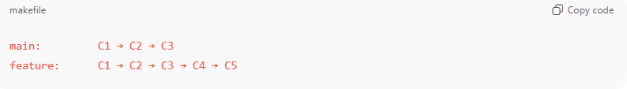
main: C1 → C2 → C3
feature: C1 → C2 → C3 → C4 → C5
- main = your main line
- feature = branch where you added commits C4 and C5
- To bring the feature changes into main:
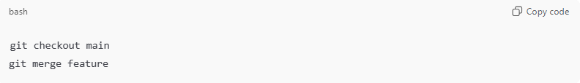
git checkout main
git merge feature
- Git compares the latest commit on both branches
- Combines changes into a new commit on main

Merge Types
# Source: AI Source: Provided by: [Data Path: Persons Table -> ID Column: 1, Name_En Column: Motasem Essam] -> From: [ChatGPT] on [2/15/2026]
- Fast-forward merge
  - Happens when the branch you’re merging is ahead of the current branch and there are no diverging commits.
  - Git just moves the branch pointer forward.
Example:
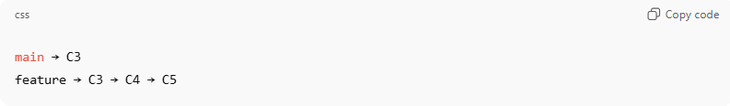
main → C3
feature → C3 → C4 → C5
After merge (fast-forward):
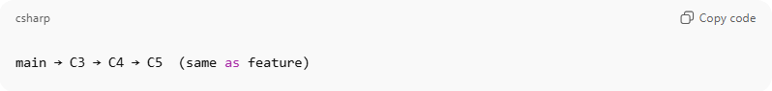
main → C3 → C4 → C5 (same as feature)

- Three-way merge
  - Happens when both branches have diverged.
  - Git creates a new merge commit combining both histories.
Example:
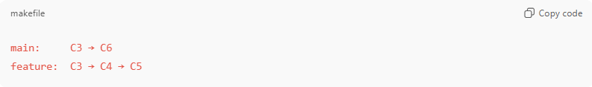
main: C3 → C6
feature: C3 → C4 → C5
- Git generates a merge commit M:
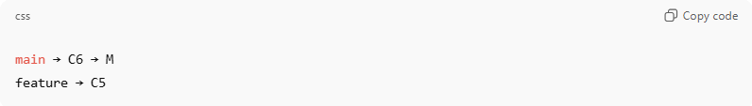
main → C6 → M
feature → C5
- Merge commit M points to both parents: C6 and C5

Common Ancestor

What is Common Ancestor in Version Control?
# Source: AI Source: Provided by: [Data Path: Persons Table -> ID Column: 1, Name_En Column: Motasem Essam] -> From: [ChatGPT] on [2/15/2026]
A common ancestor is the most recent commit shared by two branches. It is the point where the branches split apart.
Git uses the common ancestor to figure out how to merge changes between branches.

How it works
# Source: AI Source: Provided by: [Data Path: Persons Table -> ID Column: 1, Name_En Column: Motasem Essam] -> From: [ChatGPT] on [2/15/2026]
- Start with a single branch:
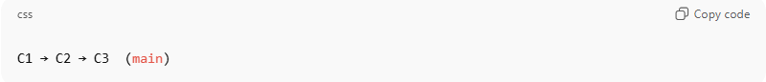
C1 → C2 → C3 (main)
- Create a new branch feature and make some commits:
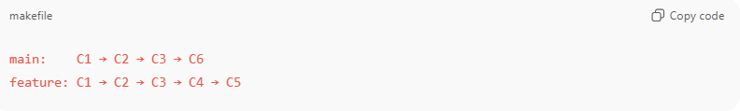
main: C1 → C2 → C3 → C6
feature: C1 → C2 → C3 → C4 → C5
- The common ancestor of main and feature = C3
- This is the last commit both branches share

Why common ancestor matters
# Source: AI Source: Provided by: [Data Path: Persons Table -> ID Column: 1, Name_En Column: Motasem Essam] -> From: [ChatGPT] on [2/15/2026]
- When Git merges two branches, it performs a three-way merge using:
  - Common ancestor (base) → C3
  - Current branch head → e.g., C6
  - Other branch head → e.g., C5
- Git compares both branches to the common ancestor to figure out what changed in each branch.

Example
# Source: AI Source: Provided by: [Data Path: Persons Table -> ID Column: 1, Name_En Column: Motasem Essam] -> From: [ChatGPT] on [2/15/2026]
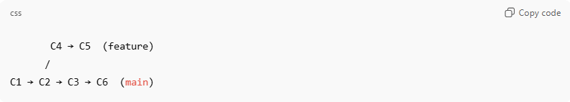
C4 → C5 (feature)
/
C1 → C2 → C3 → C6 (main)
- Common ancestor = C3
- Changes made in main = C6 – C3
- Changes made in feature = C4,C5 – C3
Git then merges these changes into a new commit if necessary.

Analogy
# Source: AI Source: Provided by: [Data Path: Persons Table -> ID Column: 1, Name_En Column: Motasem Essam] -> From: [ChatGPT] on [2/15/2026]
- Common ancestor = the fork in a road
- Branches = roads taken after the fork
- Merge = bringing both roads together again

💡 Memory trick:
# Source: AI Source: Provided by: [Data Path: Persons Table -> ID Column: 1, Name_En Column: Motasem Essam] -> From: [ChatGPT] on [2/15/2026]
Common ancestor = last shared commit before branches diverged

Diverging commits

What is Diverging commits in Version Control?
# Source: AI Source: Provided by: [Data Path: Persons Table -> ID Column: 1, Name_En Column: Motasem Essam] -> From: [ChatGPT] on [2/15/2026]
Diverging commits occur when two branches have commits that the other branch does not have, meaning the branches have separated development histories.
In other words, the branches “split” from a common point and went in different directions.

How it happens
# Source: AI Source: Provided by: [Data Path: Persons Table -> ID Column: 1, Name_En Column: Motasem Essam] -> From: [ChatGPT] on [2/15/2026]
- You start with a single branch:
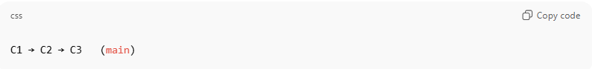
C1 → C2 → C3 (main)
- You create a new branch to work on a feature:
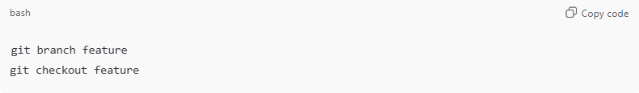
git branch feature
git checkout feature
- Both branches get separate commits:
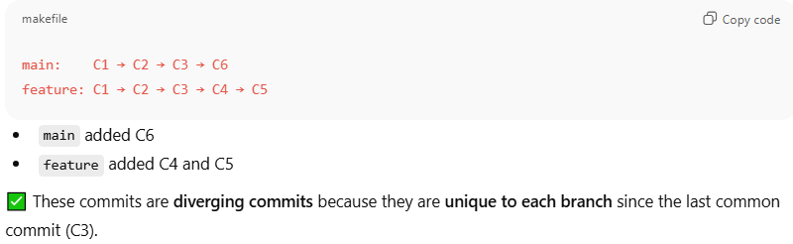
main: C1 → C2 → C3 → C6
feature: C1 → C2 → C3 → C4 → C5
- main added C6
- feature added C4 and C5
✅ These commits are diverging commits because they are unique to each branch since the last common commit (C3).

Why diverging commits matter
# Source: AI Source: Provided by: [Data Path: Persons Table -> ID Column: 1, Name_En Column: Motasem Essam] -> From: [ChatGPT] on [2/15/2026]
- When you try to merge the branches:
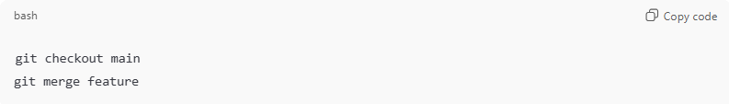
git checkout main
git merge feature
- Git detects divergence and may need a three-way merge.
- If changes overlap in the same file, a merge conflict can occur.

Visual
# Source: AI Source: Provided by: [Data Path: Persons Table -> ID Column: 1, Name_En Column: Motasem Essam] -> From: [ChatGPT] on [2/15/2026]
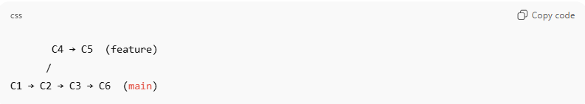
C4 → C5 (feature)
/
C1 → C2 → C3 → C6 (main)
- C4, C5, C6 = diverging commits
- C3 = last common ancestor

Key terms
# Source: AI Source: Provided by: [Data Path: Persons Table -> ID Column: 1, Name_En Column: Motasem Essam] -> From: [ChatGPT] on [2/15/2026]
- Common ancestor = the commit where branches split (here C3)
- Diverging commits = commits made on separate branches after the split

💡 Memory trick:
# Source: AI Source: Provided by: [Data Path: Persons Table -> ID Column: 1, Name_En Column: Motasem Essam] -> From: [ChatGPT] on [2/15/2026]
Diverging commits = “two branches took different paths from the same starting point.”

If you want, I can make a diagram showing diverging commits, merging, and merge commits visually — it makes the concept very easy to understand.
Do you want me to make that diagram?

Merge Conflicts
# Source: AI Source: Provided by: [Data Path: Persons Table -> ID Column: 1, Name_En Column: Motasem Essam] -> From: [ChatGPT] on [2/15/2026]
- If the same lines of a file were changed in both branches, Git can’t automatically merge.
- You must resolve conflicts manually and then commit the merge.

What is Merge Conflicts in Version Control?
# Source: AI Source: Provided by: [Data Path: Persons Table -> ID Column: 1, Name_En Column: Motasem Essam] -> From: [ChatGPT] on [2/15/2026]
A merge conflict happens when Git cannot automatically combine changes from two branches because the same part of a file was changed differently in each branch.
In other words: Git doesn’t know which change to keep, so it asks you to resolve it manually.

How it happens
# Source: AI Source: Provided by: [Data Path: Persons Table -> ID Column: 1, Name_En Column: Motasem Essam] -> From: [ChatGPT] on [2/15/2026]
- You have two branches with a common ancestor:
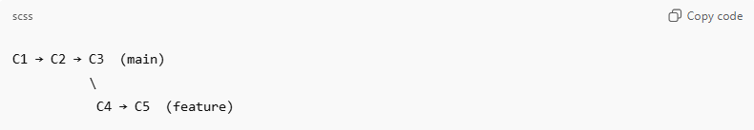
C1 → C2 → C3 (main)
\
C4 → C5 (feature)
- Both main and feature made changes to the same line in the same file.
- When you try to merge:
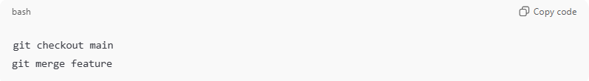
git checkout main
git merge feature
- Git attempts to merge changes.
- If changes overlap, Git stops and marks a merge conflict.

What Git does in a conflict
# Source: AI Source: Provided by: [Data Path: Persons Table -> ID Column: 1, Name_En Column: Motasem Essam] -> From: [ChatGPT] on [2/15/2026]
Git modifies the file to show conflict markers:
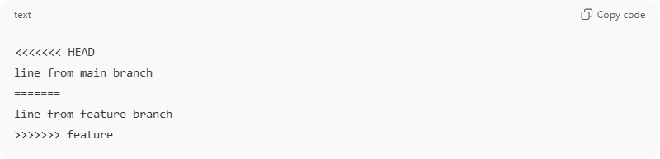
<<<<<<< HEAD
line from main branch
=======
line from feature branch
>>>>>>> feature
- <<<<<<< HEAD → current branch’s content
- ======= → separates changes
- >>>>>>> feature → changes from merged branch
You must edit the file to choose or combine changes, then:
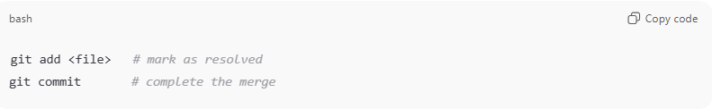
git add <file> # mark as resolved
git commit # complete the merge

Key points
# Source: AI Source: Provided by: [Data Path: Persons Table -> ID Column: 1, Name_En Column: Motasem Essam] -> From: [ChatGPT] on [2/15/2026]
- Merge conflicts only happen when branches change the same lines
- Git can automatically merge files that don’t overlap
- Conflicts are temporary — you resolve them before finishing the merge

Commands to manage conflicts
# Source: AI Source: Provided by: [Data Path: Persons Table -> ID Column: 1, Name_En Column: Motasem Essam] -> From: [ChatGPT] on [2/15/2026]
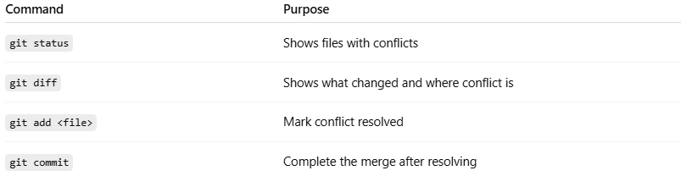
Command | Purpose
git status | Shows files with conflicts
git diff | Shows what changed and where conflict is
git add <file> | Mark conflict resolved
git commit | Complete the merge after resolving

Analogy
# Source: AI Source: Provided by: [Data Path: Persons Table -> ID Column: 1, Name_En Column: Motasem Essam] -> From: [ChatGPT] on [2/15/2026]
- Two people edited the same sentence in a shared document → Git can’t decide which version to keep → you resolve it manually.

💡 Memory trick:
# Source: AI Source: Provided by: [Data Path: Persons Table -> ID Column: 1, Name_En Column: Motasem Essam] -> From: [ChatGPT] on [2/15/2026]
Merge conflict = Git says “I don’t know which change to keep — you decide.”

If you want, I can make a diagram showing branches, diverging commits, merge, and conflict resolution visually — it makes this concept very clear.
Do you want me to make that diagram?

Merge Commit

What is Merge Commit in Version Control?
# Source: AI Source: Provided by: [Data Path: Persons Table -> ID Column: 1, Name_En Column: Motasem Essam] -> From: [ChatGPT] on [2/15/2026]
A merge commit is a special commit that combines changes from two branches.
It is created when you merge a branch into another and Git needs to record a new commit that has two or more parents.

Key points
# Source: AI Source: Provided by: [Data Path: Persons Table -> ID Column: 1, Name_En Column: Motasem Essam] -> From: [ChatGPT] on [2/15/2026]
- Has multiple parents
  - Unlike normal commits, which have one parent, a merge commit can have two or more parents.
  - This is how Git keeps track of history from multiple branches.
- Stores combined snapshot
  - The merge commit contains a snapshot of all changes from both branches.
  - If there were conflicts, it reflects the resolved content.
- Maintains history
  - Merge commits let Git preserve the full branch structure and show how branches were integrated.

Example
# Source: AI Source: Provided by: [Data Path: Persons Table -> ID Column: 1, Name_En Column: Motasem Essam] -> From: [ChatGPT] on [2/15/2026]
Suppose you have:
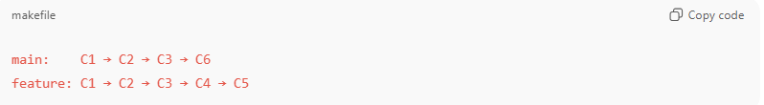
main: C1 → C2 → C3 → C6
feature: C1 → C2 → C3 → C4 → C5
You merge feature into main:
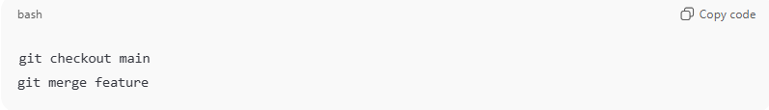
git checkout main
git merge feature
- Git creates a merge commit M:
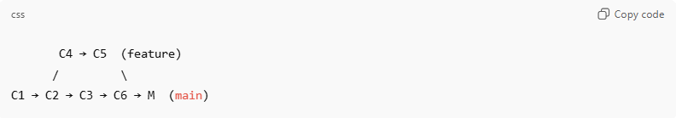
C4 → C5 (feature)
/ \
C1 → C2 → C3 → C6 → M (main)
- Merge commit M points to C6 (main) and C5 (feature) as parents

Fast-forward merge vs Merge commit
# Source: AI Source: Provided by: [Data Path: Persons Table -> ID Column: 1, Name_En Column: Motasem Essam] -> From: [ChatGPT] on [2/15/2026]
- Fast-forward merge
  - Branch can just move forward; no new commit needed.
  - Example: main is behind feature, no divergent commits
- Merge commit (non-fast-forward)
  - Happens when branches diverged
  - Git creates a new commit with two parents

Commands
# Source: AI Source: Provided by: [Data Path: Persons Table -> ID Column: 1, Name_En Column: Motasem Essam] -> From: [ChatGPT] on [2/15/2026]
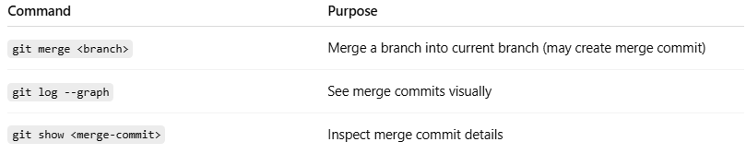
Command | Purpose
git merge <branch> | Merge a branch into current branch (may create merge commit)
git log --graph | See merge commits visually
git show <merge-commit> | Inspect merge commit details

Analogy
# Source: AI Source: Provided by: [Data Path: Persons Table -> ID Column: 1, Name_En Column: Motasem Essam] -> From: [ChatGPT] on [2/15/2026]
- Branches = two separate paths
- Merge commit = a bridge that combines both paths
- Parents = points where the bridge connects

💡 Memory trick:
# Source: AI Source: Provided by: [Data Path: Persons Table -> ID Column: 1, Name_En Column: Motasem Essam] -> From: [ChatGPT] on [2/15/2026]
Merge commit = a snapshot of combined changes + multiple parents → preserves branch history

Commands
# Source: AI Source: Provided by: [Data Path: Persons Table -> ID Column: 1, Name_En Column: Motasem Essam] -> From: [ChatGPT] on [2/15/2026]
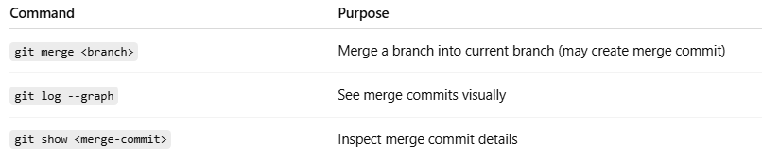
Command | Description
git merge <branch> | Merge another branch into current branch
git status | Check for conflicts
git log --graph | See merge history visually

Analogy
# Source: AI Source: Provided by: [Data Path: Persons Table -> ID Column: 1, Name_En Column: Motasem Essam] -> From: [ChatGPT] on [2/15/2026]
- Branch = road
- Merge = bridge connecting two roads
- If both roads added different things at the same place → conflict → need manual adjustment

💡 Memory trick:
# Source: AI Source: Provided by: [Data Path: Persons Table -> ID Column: 1, Name_En Column: Motasem Essam] -> From: [ChatGPT] on [2/15/2026]
Merge = combine changes from two branches → new commit if needed

